Banner K50 Pro Advanced Mode Full AOI Design

Part Number Tested: K50PTVKQ

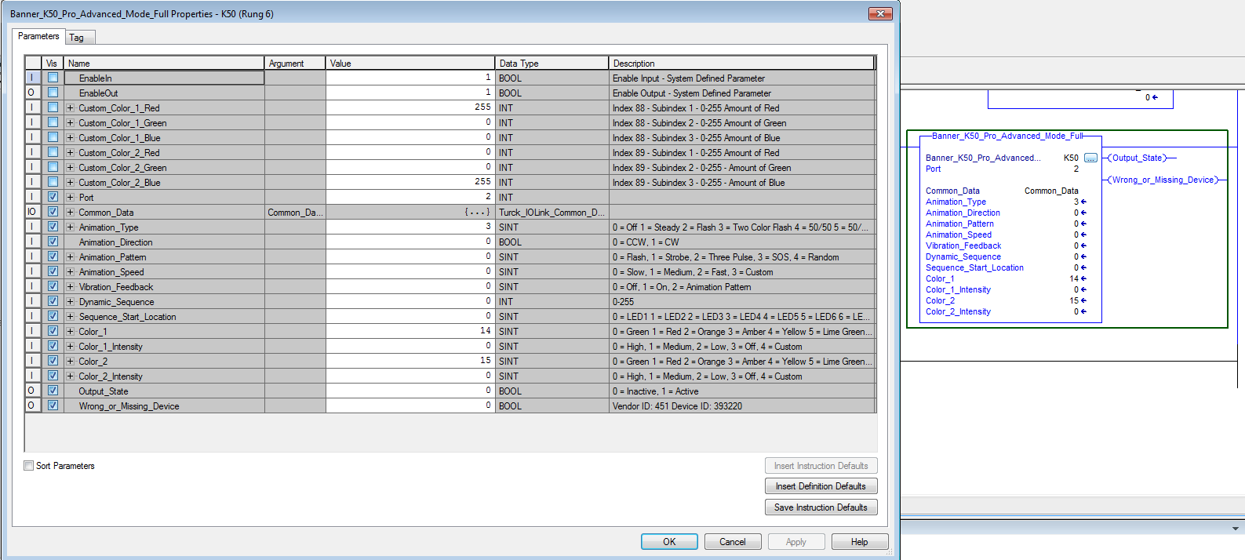

Not Pictured but also controls:

Index 80 – Must be = 2 (Advanced Mode) and if needed writes it.